NATIONAL UNIVERSITY OF SINGAPORE

EXAMINATION FOR
(Semester II: 2009/2010)

EE4212 – COMPUTER VISION
April / May 2010 - Time Allowed: 2 Hours

Instructions to Candidates:
1. This paper contains FOUR (4) questions and comprises FIVE (5) printed pages.
2. Answer all FOUR (4) questions.
3. All questions carry equal marks.
- This is a CLOSED BOOK examination but candidates are allowed to bring in ONE (1) A4 sheet of paper, on which they may write any information, into the examination hall.
5. Programmable calculators can be used in the examination.

Q1
- The motion field is particularly simple when a perspective projection camera is moving without rotation in a fixed environment. All parts of the image then appear to be streaming away from the “focus of expansion’’ (FOE). Let E(x, y, t) represent the brightness of the image at pixel location (x, y) at time t. Define “critical’’ points to be those points where E_{t} = 0 where subscripts denote partial differentiation. Show that (x − x₀)E_{x} + (y − y₀)E_{y} = 0 at “critical’’ points. Given that you have obtained n “critical’’ points, propose a scheme to estimate the position of the FOE using the above equation, without having to estimate the optical flow. What is the advantage of such a method compared to one which estimates the optical flow and then obtain the FOE as the intersection of all the optical flow vectors?
(8 marks)

- Given that the scene in view is actually a fronto-parallel plane (i.e., the depth is the same for all points), with the camera again making pure translation, can you now make use of this fact and formulate a similar scheme to the above (Q1(a)) which can estimate (x₀, y₀ ) without having to estimate the optical flow, and yet it uses all image point measurements, rather than just those at critical points. State clearly how you would obtain the solution for all the variables involved.
(7 marks)

- If the camera is now making a full general motion with both rotation and translation, the estimation of the 3D motion becomes much more complicated. However, if you are told that the location of the FOE is at the image location (0, 0), and you are given n optical flow measurements (u_{i}, v_{i}) at the image points (x_{i}, y_{i}) for i = 1 to n, can you write down the linear system of equations that estimates the rotational parameters (ω_{x}, ω_{y}, ω_{z})?
(5 marks)

- In Figure 1 below, the two rectangular figures are translating horizontally in the opposite directions as indicated by the arrows. Indicate the respective perceived motions if you are looking through the apertures 1, 2, and 3. Explain your answers for apertures 1, 2, and 3 respectively.
1
2
3
Figure 1. Two rectangles translating horizontally in the opposite directions.
(5 marks)
Q2
- You have estimated the fundamental matrix F from the 8-point algorithm. Explain how you can use F to help you obtain epipolar lines on the right image given feature points (x_{i} ,y_{i} ) in the left image.
(3 marks)

- You find that the epipolar lines obtained in Q2(a) do not intersect at one point in the projective plane P². Discuss if this outcome is correct, and if not, describe how you can rectify this problem so that F has the desired property.
(4 marks)

- The classical 8-point algorithm has been criticized that the minimization criteria 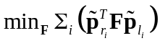 is not geometrically meaningful. Can you explain what you understand by this statement?
(4 marks)

- You are given the following estimate of the essential matrix E of a stereo pair:

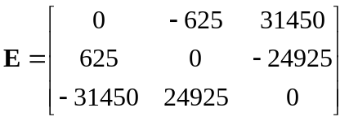

Given that the focal length of the left camera of the stereo pair is f = 15.6mm, determine the position of the left epipole (in inhomogeneous coordinates and in mm). For this particular E estimate given, how do you know there exists a solution to the left epipole, even without imposing the rank 2 constraint on E or explicitly checking the rank of E?
(10 marks)

- Given the image pair below in Figure 2, discuss the problem(s) that you might encounter when trying to establish feature correspondence.
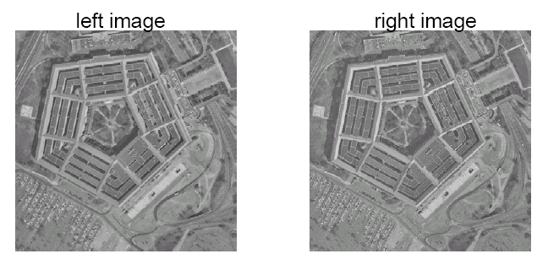
Figure 2. A stereo image pair. (4 marks)

